Welsh Harp Environmental Education Centre

Birchen Grove, London, NW9 8RY

Venue Hire - Booking Request Form

Your contact details:
Name Click here to enter text.
Email address Click here to enter text.
Telephone number Click here to enter text.
Company name Click here to enter text.
Company address Click here to enter text.

Information about the booking you would like to make:
Date Click here to enter a date.
Half day, 4 hours, £140: morning ☐ afternoon ☐
Full-day, 8 hours, £240 ☐

Room layout:
Number of people attending Click here to enter text.
Conference style, up to 40 people ☐
Seated at tables, up to 25 people ☐

Other resources required:
Wifi ☐ Projector ☐ Projector & Laptop ☐
Flipchart paper and pens ☐

Use of kitchenette including refreshments ☐
Tea, coffee, water, cordial, biscuits, £2.00 per person half-day, minimum spend £20, self-service: How many people

Use of kitchenette, bringing your own refreshments ☐

Please include a description of the purpose of your booking to help us to meet your needs:
Click here to enter text.

Thank you very much for your request. Please return your completed form to the following address and we will get back in touch as soon as possible - welshharpcentre@thames21.org.uk

Conditions of Venue Hire
For the purposes of this document the Welsh Harp Environmental Education Centre is known as the Centre.

- It is not permitted to remove from or bring wildlife to the Centre.

- Smoking is not permitted anywhere at the Centre.

- Thames21 will invoice for payment of the booking prior to it taking place.

- Three weeks’ notice of a booking cancelation must be provided. Following this date 50% will be retained by Thames21 unless another booking can be made to fill the vacated date.

- The specified hire time must include the hirer’s time to set up and pack away.

- The premises must be left in a clean and tidy state as found. A £10 cleaning charge will be made to the hirer should the premises not be left in a clean and tidy state.

- The hirer may not alter or add to the internal space, or remove any furniture or fittings.

- The hirer must not fix materials to the walls by means of any “puncture” or tape. Limited use of Bluetac or similar temporary fixative is permitted. The use of drawing pins or sticky tape is strictly prohibited.

- The hirer must provide full details of the intended use of the hire space, which may not be used for any other purpose than that designated by the hirer.

- Any electrical equipment brought into the Centre must be by agreement with Thames21. The hirer is responsible for the health and safety requirements for any such equipment and will be liable for any loss, injury or damage caused to person(s) or to the building or site. The hirer must remove any equipment brought in at the termination of the booking period.

- All noise must be kept to an acceptable level and should at no time be considered a nuisance to the surrounding environment.

- Any damage or breakages must be paid for in full by the hirer.

- Rooms are hired entirely at the hirer’s own risk. Thames21 cannot be held responsible for loss or damage to the hirer’s property.

- Attendees are permitted to park at their own risk in the limited amount of parking spaces available at the Centre.

- Thames21 shall have the right to enter the hired space at any time in an emergency or otherwise with reasonable notice.

- The hirer will observe the limits on numbers and ensure maximum capacity as stated at the point of booking are not exceeded.

- All businesses, public sector organisations and incorporate bodies must have Public Liability insurance in force which covers their hire of the Centre. The minimum indemnity limit is £2million.

Information for the Hirer
- Rooms are equipped with power points, however please bring own extension leads as required.

- Rooms are available for hire between 9am and 5pm Mon - Sun, and can be hired either by the day or half-day.

- Free WiFi is available to all meeting delegates. Access code available upon arrival.
- Tea, coffee, milk, cordial and water may be supplied on a self-service basis at a cost of £2.00 per person/half day, and should be indicated on the booking form.

Directions to the Centre
www.thames21.org.uk
Registered Charity Number: 1103997
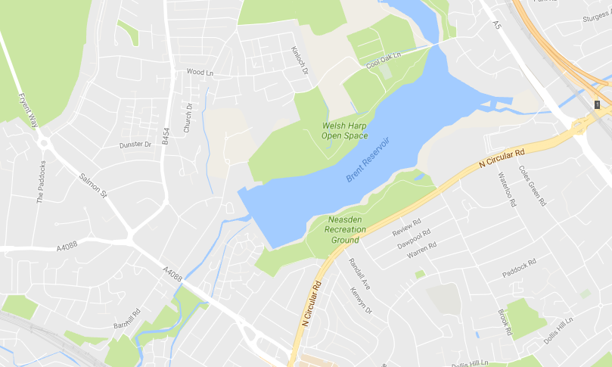

Address: Welsh Harp Environmental Education Centre, Birchen Grove, London, NW9 8RY
Buses servicing the area: 83, 182, 245, 297, 302 pass within a ten minute walk of the Centre.

Driving to the Centre: Birchen Grove is a minor road off Blackbird Hill with traffic lights at the junction. Follow the signs to the garden centre, we share their drive. Drivers should stop in the car park, not on the drive.
www.thames21.org.uk
Registered Charity Number: 1103997

