Community Modelling: Water Quality in North London

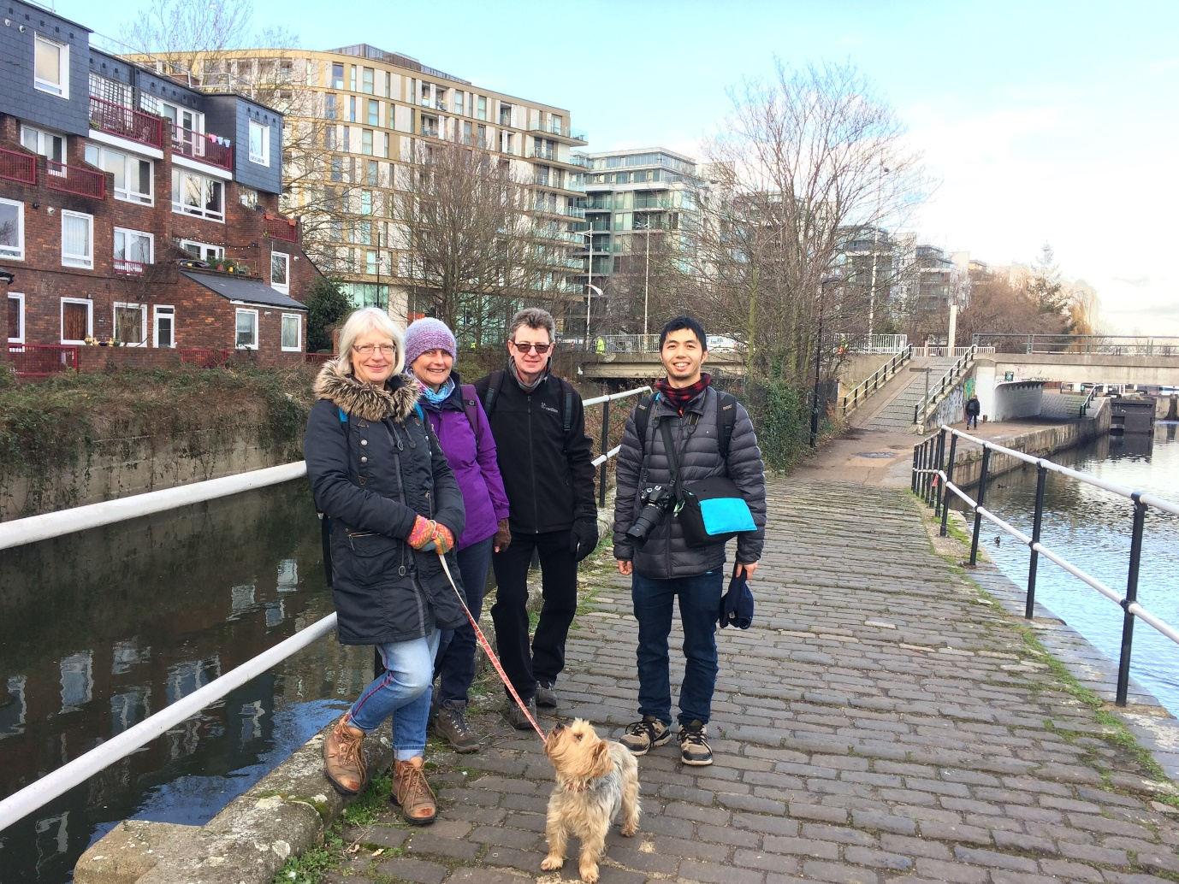
Contents
Abstract 3
1. Introduction 4
2. Community Modelling 8
3. INCA 9
4. Scenarios 10
5. Results 12
6. Conclusions 14
7. References 15

Abstract

The water quality community modelling project researched three catchments in North London over a nine month period, establishing the pressures on water quality before potential solutions were identified and analysed by the three community modelling groups.
The River Lea and its tributaries in North London are failing to achieve ‘good’ ecological status. Understanding the pressures faced by Salmons Brook, Pymmes Brook and Ching Brook as heavily urbanised rivers, receiving contaminated water through misconnected drains, over-whelmed separate sewers and urban diffuse run-off, has enabled the groups to develop a bespoke model in which scenarios can be tested, solutions identified and their benefits quantified.

Introduction

Community modelling is a process empowering local people by giving them access to resources that can be used to help understand and quantify complex environmental issues, test solutions and aid decision making. It works by combining communities’ local knowledge with academic models and an NGO acting as a trusted facilitator; in this instance the issue of water quality was explored.
This project was partially shaped by three previous projects; ‘Community Modelling in Otley’, ‘Ryedale Flood Research Group’ and ‘Community Modelling in the River Kennet’, which investigated flood risk and water quality respectively.
The community modelling project was introduced by Oxford University to Thames21 who wished to explore other options to mitigate water pollution in three tributaries of the River Lea. Following strong feedback on the issues by members of the public, the programme aims to combine an evidence-based approach with the catchment-based approach to guide development and sustain a healthy river for future generations. Over the nine month period, the groups developed three bespoke models for each catchment (Pymmes, Salmons and Ching), trialling various scenarios to investigate the potential benefits of constructed wetlands.
Community modelling is underpinned by the notion of transdisciplinary engagement between social and physical scientists and affected local people (Becker, Odoni, Landström & Whatmore, 2017).
The objectives of this project were to:
- Enable an enhanced understanding of the sources of pollution (thematic and geographic)
- Identify strategically important areas to deliver water quality improvements at a catchment scale
- Investigate and analyse the impact of introducing local actions
  - Prioritise solutions (including type and location) which can be implemented in the Salmons Brook, Pymmes Brook and Ching Brook catchments
  - Catchment
Located in North London, three significant tributaries to the River Lea; the project investigates the Salmons Brook, Pymmes Brook and Ching Brook (figure 1). All three rivers are heavily urbanised, and as a consequence suffer from urban diffuse pollution, which is difficult to trace and attribute (Whitehead, 2017). Pymmes Brook catchment is 41.37km^{2,} Salmons Brook catchment is 23.58km² and Ching Brook catchment is 19.39km² (EA, 2018). The lower Salmons Brook is a recipient of Deephams Sewage Treatment Plant. The area occupied by the three catchments is relatively flat, with elevations ranging from 130m to 10mAOD. The upper catchment of the Salmons Brook catchment is agricultural. A separate sewer system treats wastewater, from both industrial and commercial sources. Misconnected plumbing, when wastewater effluent or trade effluent is connected to the surface water pipe can cause pollution. This can lead to hydraulic overloading, surcharging and flooding (Whitehead, 2017).

  - Rationale
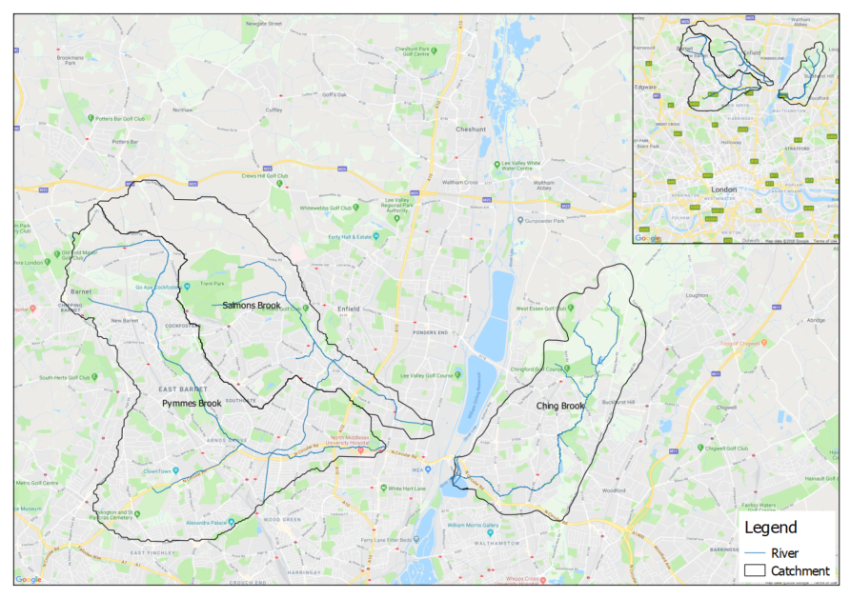
The Salmons Brook catchment has six green infrastructure projects installed; from constructed wetlands to swales. Schemes such as Firs Farm, Enfield has been highly commended for a SWIG Award, and won a Living Waterways Award. The treatment efficiency of these systems has been monitored by Gilbert (2016) and the EA (2017) demonstrating a constructed wetlands ability to retain and remove nutrients. The six projects installed in the Salmons Brook catchment, under the umbrella project ‘Salmons Brook Healthy Rivers Challenge’ collectively reduce nitrate and phosphate concentrations. The community modelling project aimed to build on this this in-situ monitoring of constructed wetlands in order to propose hypothetical solutions for improving water quality in the three catchments.
Figure 1-2 A map showing the three river catchments located in North London.

Community Modelling

The community modelling water quality project built upon previous work undertaken by the Otley Community Flood Modelling Group (OCFM), Ryedale Flood Research Group and the River Kennet Environmental Competency Group (Kennet ECG). All projects highlighted the benefits of engaging with local residents to address local environmental issues. Environmental competency groups are designed to create a space in which those most directly affected by the problem can interrogate expert knowledge and bring their experiences to bear on how the problem is framed and different courses of action (Whitehead, 2016).

  - Recruitment
Volunteer recruitment occurred in July 2017, combing social media, the volunteer database and word of mouth, members for each group were recruited.
  - Knowledge and Information
Towards the start of the project, it was agreed to use minimal jargon when disseminating and discussing potential solutions and the project’s aims. For example terms such as ‘rainscapes’ were used in place of ‘SuDS’., The groups’ produced catchment maps to highlight local knowledge of its issues. Known incidents of pollution were mapped by participants, as well as a GIS layer showcasing the sewer network in London provided by Thames Water. Publically available datasets such as the EA ++ Catchment Data Explorer were demonstrated to the groups.
  - Project structure
The three community groups met for their introductory meetings in a community venue; in all instances the local library. The overarching aim of the first meetings was to introduce the project, create a cohesive environment in which members could meet and establish relations, quell any issues or questions that could arise and finally to introduce the software. The groups were encouraged to take any material, in this instance maps and a copy of the software, away with them.
One main theme which arose from all the meetings was the necessity to gain a greater understanding of the catchments, in the form of a walk, and develop a deeper understanding of potential solutions and how they have been previously implemented into North London catchments; specifically the Borough of Enfield.
Monthly meetings were organised in which the groups could share knowledge, perform mapping exercises and interrogate the model to develop a range of scenarios which could be tested.
  - Walkovers and site visits
A tour of previously completed constructed wetlands was undertaken to enable the groups to witness first-hand what a constructed wetland and other features could look like. Three sites were chosen to show different aspects including, Firs Farm, Houndsden Spinney and, Glenbrook.
All three modelling groups took park in an introductory walkover of their catchment in October 2017. This walk familiarised the participants with each catchment, demonstrating the constraints and areas in which solutions could be implemented. Many of the participants had a sense of affinity to certain areas which they frequented;, through walking the entire catchment the groups were shown new areas and developed their understanding of viewing a river as a connected catchment in which various stresses threaten its overall health. Whilst out on the walks, the participants could interact with the local community and ‘Friends of’ groups, exchanging ideas and increasing awareness of the project. Other potential projects were identified through scrutinising where Thames Water’s surface water sewers run under green spaces.
Once potential areas across the catchments were suggested, the groups undertook site visits to scope out feasibility. Whilst undertaking site visits additional issues to the catchments were noticed, such as localised flooding.

INCA

INCA is a semi-distributed process-based model which simulates the transformation of rainfall into runoff and the propagation of water through a river network (Wade et al., 2002a). INCA uses weather data, land use data, EA water quality observation data and river network data to simulate water quality in a catchment. Within the model various parameters can be changed to simulate different scenarios and the potential effects on water quality. Numerous studies and articles regarding model conceptualisation and model application are have been published, for example Whitehead et al. (1998) who presents model structure, Wade et al. (2002a) who described some modifications to the INCA-N structure, Wade et al. (2002b), who presented the INCA-P model structure, and Lázár et al. (2010), who described the INCA-Sediment model structure. The hydrological and water quality sub-models of INCA have been applied to several basins across the UK and Europe, and, in particular, to the River Thames catchment (Bussi et al., 2017, 2016a, 2016b; Crossman et al., 2013; Jin et al., 2012; Lu et al., 2016; Whitehead et al., 2016, 2013) and the River Lee catchment (Flynn et al., 2002; Snook and Whitehead, 2004).

Scenarios

Green infrastructure is well documented (CIRIA 2007, Ellis 2015) to mitigate pollution, reduce flood risk and create biodiversity. It can include SuDS, retention ponds, constructed wetlands and green roofs. As water quality was a key aim for this project, constructed wetlands were tested for treating a river using a catchment-based approach. Constructed wetlands such as Firs Farm, Enfield have been observed to reduce 65% of nitrate, 69% of ammonia, 68% of phosphate and 78% of faecal bacteria concentrations (Gilbert, 2016), as well as having additional benefits including reducing flood risk to properties.
The groups took similar approaches to identifying and assessing feasibility of sites for implementing constructed wetlands. Combining open access GIS, (sourced from OS, EA, SCIMAP, CaBA) and local knowledge the groups undertook several mapping workshops to identify areas of open space above or adjacent to gravity sewers. Initially 50 sites were proposed across the three catchments; after assessing for feasibility through investigating Thames Water Sewer Network data, site visits and LIDAR data, this was reduced to 34. Figure 2 shows the site locations of the potential wetlands identified by the community modellers.
Once the potential sites were mapped, bespoke models for the three tributaries could be designed and tested. Potential wetlands can be tested individually or in combination with other wetlands this can identify strategically important areas in which significant improvements can be predicted. The size of wetlands and the areas treated by the wetland contribute to more significant improvements in water quality
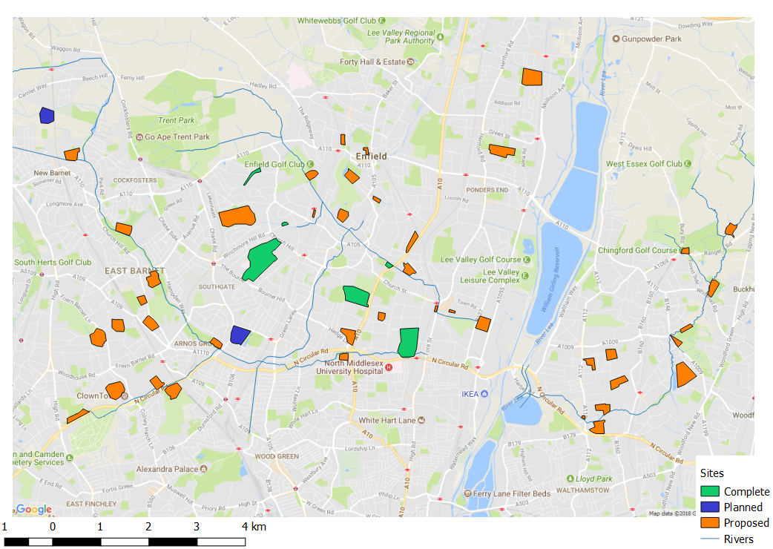
Figure 4-1 A map of the three catchments showing established, planned and proposed sites for constructed wetlands. Identified by the Community Modellers using Thames Water Sewer Network and site visits.

Results

  - 4.1 Combined effect of implementing constructed wetlands across a catchment
Constructed wetlands can be represented in INCA by increasing the residence time by a factor of 10, changing the land use and creating a new reach in which the surface water would be treated. Figures 2, 3 and 4 show the modelled results of the scenarios. The scenarios were modelled investigating the overall improvements at a catchment scale and individually at a reach scale: a reach scale is defined as the upstream area treated by the constructed wetland. As expected, results at a reach scale were significantly larger, demonstrating the benefits produced by a constructed wetland. Once the results were considered at a catchment scale, the benefits are reduced, however both the Pymmes Brook and Ching Brook are predicted to gain ‘good ecological status’ with the implementation of the scenarios – currently only one stretch of river in outer London has been given this status.
It should be noted, observed improvements in water quality at Firs Farm are greater than the simulated improvements by the model in the scenario runs. Thus, INCA is using a conservative estimate. Additionally, the sizing of wetlands could be increased at certain sites, which could increase the overall improvement to the catchment. Interventions to reduce nutrients in the upper river catchment, could create a more substantial improvement in the lower catchment, as suggested by Feld, Fernandes & Ferreira (2018). This could be modelled in the Salmons Brook catchment, where the upper catchment is dominated by agricultural land-use.
Figure 5-1 Water quality improvements for the Salmons Brook catchment showing a 7% reduction in ammonium once 5 wetlands are implemented. The darker blue area represents the baseline data, the lighter blue area represents the scenario, the green line represents the threshold required to achieve ‘good’ status for a water body as defined by the Water Framework Directive.
Figure 5-2 Water quality improvements for the Pymmes Brook catchment, showing a 28% reduction in ammonium once 16 wetlands are implemented. Dark blue bar shows before the scenario and light blue shows after the scenario, the green line indicates the threshold to achieve ‘good’ water body status as defined by the Water Framework Directive.
Figure 5-3 Water quality improvements in the Ching Brook catchment showing a 56% reduction in ammonium once 9 wetlands are implemented. Dark blue area represents before the scenario, light blue area represents the scenario data, and the green line represents the threshold to achieve ‘good’ water body status as defined by the Water Framework Directive.

Conclusions

The results demonstrate how appropriately sited constructed wetlands on a catchment scale can achieve water body status change for rivers Constructed wetlands have the ability to deliver ‘Good’ waterbody status to the Pymmes and Ching Brooks and have the ability to improve water quality on the Salmons Brook. Additionally, constructed wetlands can improve water quality at a larger, catchment scale, thus helping to implement WFD targets whilst improving the environment. Constructed wetlands have the potential to provide multiple benefits including reducing of flood risk, creating of social amenities, increasing property prices, however these benefits have not been quantified.
The community modelling process has significant potential to enable communities and authorities to understand complex environmental issues, and test collaborative evidence-based solutions which can highlight strategic areas in a catchment. The success of this water quality community modelling project has led to funding being awarded to conceptualise constructed wetlands in the Ching Brook, building on the evidence of water quality improvements in order to prioritise wetland implementation in the catchment.
The potential benefits of constructed wetlands on water quality, identified by the community modelling water quality project has led to an opportunity to investigate their potential benefits on reducing flood risk in those same three catchments.

References

Bussi, G., Dadson, S.J., Whitehead, P.G., Prudhomme, C., 2016a. Modelling the future impacts of climate and land-use change on suspended sediment transport in the River Thames (UK). J. Hydrol. 542, 357–372
Becker, M., Odoni, N., Landström, C., Whatmore, S. 2017 Community modelling: incorporating local knowledge into hydraulic flood modelling in Otley, Yorkshire School of Geography and the Environment
Bussi, G., Janes, V., Whitehead, P.G., Dadson, S.J., Holman, I.P., 2017. Dynamic response of land use and river nutrient concentration to long-term climatic changes. Sci. Total Environ. 590–591, 818–831
Bussi, G., Whitehead, P.G., Bowes, M.J., Read, D.S., Prudhomme, C., Dadson, S.J., 2016b. Impacts of climate change, land-use change and phosphorus reduction on phytoplankton in the River Thames (UK). Sci. Total Environ. 572, 1507–1519
Crossman, J., Whitehead, P.G., Futter, M.N., Jin, L., Shahgedanova, M., Castellazzi, M.S., Wade, A.J., 2013. The interactive responses of water quality and hydrology to changes in multiple stressors, and implications for the long-term effective management of phosphorus. Sci. Total Environ. 454–455, 230–44
Ellis, J.B., Butler, D., 2015. Surface water sewer misconnections in England and Wales: Pollution sources and impacts. Sci. Total Environ. 526, 98–109
EA. 2018 Catchment data explorer http://environment.data.gov.uk/catchment-planning/
Feld, C.K., Fernandes, M., Ferreira, M.T., Hering, D., Omerod, S.J., Venohr, M., Gutiérrez - Cánovas, C. (2018) Evaluating riparian solutions to multiple stressor problems in river ecosystems - a conceptual study Water Research
Flynn, N.J., Paddison, T., Whitehead, P.G., 2002. INCA Modelling of the Lee System: strategies for the reduction of nitrogen loads. Hydrol. Earth Syst. Sci. 6, 467–484
Futter, M.N., Erlandsson, M.A., Butterfield, D., Whitehead, P.G., Oni, S.K., Wade, A.J., 2014. PERSiST: a flexible rainfall-runoff modelling toolkit for use with the INCA family of models. Hydrol. Earth Syst. Sci. 18, 855–873
Gilbert, N. (2016) Improvements in water quality by integrated constructed wetlands in the Moore Brook catchment.
Jin, L., Whitehead, P.G., Futter, M.N., Lu, Z., 2012. Modelling the impacts of climate change on flow and nitrate in the River Thames: assessing potential adaptation strategies. Hydrol. Res. 43, 902–916
Landström, C., Whatmore, S.J., Lane, S. N., Odoni, N.A., Ward, N. Bradley, S. 2011 Co-producing flood risk knowledge: redistributing expertise in ‘participatory modelling’ Environment and Planning A, 43/7: 1617-1633
Lázár, A.N., Butterfield, D., Futter, M.N., Rankinen, K., Thouvenot-Korppoo, M., Jarritt, N.P., Lawrence, D.S.L., Wade, A.J., Whitehead, P.G., 2010. An assessment of the fine sediment dynamics in an upland river system: INCA-Sed modifications and implications for fisheries. Sci. Total Environ. 408, 2555–2566
Lu, Q., Futter, M.N., Nizzetto, L., Bussi, G., Jürgens, M.D., Whitehead, P.., 2016. Fate and Transport of Polychlorinated Biphenyls (PCBs) in the River Thames Catchment – Insights from a Coupled Multimedia Fate and Hydrobiogeochemical Transport Model. Sci. Total Environ. 572, 1461–1470
Patroncini, D., 2013. Water quality investigations of the River Lea (NE London). University of Bedfordshire.
Revitt, D.M., Ellis, J.B., 2016. Urban surface water pollution problems arising from misconnections. Sci. Total Environ. 551–552, 163–174. doi:10.1016/j.scitotenv.2016.01.198
Smith, G., Beare, M., Boyd, M., Downs, T., Gregory, M., Morton, D., Brown, N., Thomson, A.G., 2007. UK Land Cover Map Production Through the Generalisation of OS MasterMap®. Cartogr. J. 44, 276–283
Snook, D.L., Whitehead, P.G., 2004. Water quality and ecology of the River Lee: mass balance and a review of temporal and spatial data. Hydrol. Earth Syst. Sci. 8, 636–650
Wade, A.J., Durand, P., Beaujouan, V., Wessel, W.., Raat, K.J., Whitehead, P.G., Butterfield, D., Rankinen, K., Lepisto, A., 2002a. A nitrogen model for European catchments: INCA, new model structure and equations. Hydrol. Earth Syst. Sci. 6, 559–582
Wade, A.J., Whitehead, P.G., Butterfield, D., 2002b. The Integrated Catchments model of Phosphorus dynamics (INCA-P), a new approach for multiple source assessment in heterogeneous river systems: model structure and equations. Hydrol. Earth Syst. Sci.
Whitehead, P.G. 2017 Active Water Resilience Incorporating local knowledge in water management of the River Kennet catchment
Whitehead, P.G., Crossman, J., Balana, B.B., Futter, M.N., Comber, S., Jin, L., Skuras, D., Wade, A.J., Bowes, M.J., Read, D.S., 2013. A cost-effectiveness analysis of water security and water quality: impacts of climate and land-use change on the River Thames system. Philos. Trans. A. Math. Phys. Eng. Sci. 371
Whitehead, P.G., Leckie, H., Rankinen, K., Butterfield, D., Futter, M.N., Bussi, G., 2016. An INCA model for pathogens in rivers and catchments: Model structure, sensitivity analysis and application to the River Thames catchment, UK. Sci. Total Environ. 572, 1601–1610
Whitehead, P.G., Wilson, E., Butterfield, D., 1998a. A semi-distributed integrated nitrogen model for multiple source assessment in catchments (INCA): Part I — model structure and process equations. Sci. Total Environ. 210–211, 547–558
Whitehead, P.G., Wilson, E., Butterfield, D., Seed, K., 1998b. A semi-distributed integrated flow and nitrogen model for multiple source assessment in catchments (INCA): Part II — application to large river basins in south Wales and eastern England. Sci. Total Environ. 210–211, 559–583

